**Program Twelve Part One:**

**Part A:**

//summary: This program uses an exception handler to find errors in inputs of a simple caculator. This caculator can

//add, subtract, multiply, and divide.

//name: Jenna Wolf

//class: Fundamentals of Programming, CS155 - 01

//instructor: Dr. Art Kazmierczak

//date: 11/06/2023

import java.util.Scanner;

public class Main

{

public static void main(String[] args)

{

Scanner input = new Scanner(System.in); //names the input

boolean valid = false; //holds the valid data and sets it to false

double num1 = 0, num2 = 0; //holds the num1 and num2 data sets it to 0

char operator; //holds the operator data

while(!valid) //loop goes until valid inputs are made

{

try {

//takes in num1 data (error occurs if numbers are not input)

System.out.print("Please enter a number: ");

num1 = Double.parseDouble(input.nextLine());

//takes in the operator (error occurs if improper opperator is input)

System.out.print("Please enter an operator (+, -, *, or /): ");

operator = input.nextLine().charAt(0);

if(operator != '+' && operator != '-' && operator != '*' && operator != '/')

throw new IllegalArgumentException("Ilegal Operator!");

//takes in num2 data (error occurs if numbers are not input)

System.out.print("Please enter another number: ");

num2 = Double.parseDouble(input.nextLine());

//based on the operator, statement is output and caculations are made

if(operator == '+')

System.out.println(num1 + " + " + num2 + " = " + (num1 + num2)); //+ operation

else if(operator == '-')

System.out.println(num1 + " - " + num2 + " = " + (num1 - num2)); //- operation

else if(operator == '*')

System.out.println(num1 + " * " + num2 + " = " + (num1 * num2)); //* operation

else if(operator == '/')

{

if(num2 == 0) //if the second number input is 0, an error occurs

throw new ArithmeticException("You cannot divide by 0!");

else

System.out.println(num1 + " / " + num2 + " = " + (num1 / num2)); // / operation

}

valid = true;

}

catch(NumberFormatException ex) { //catches when a non number is entered

System.out.println("Error: please enter a number!");

}

catch(ArithmeticException ex) { //catches when a 0 is entered for the second part of division

System.out.println("Error: " + ex.getMessage());

}

catch(IllegalArgumentException ex) { //catches when a wrong operator is entered

System.out.println("Error: " + ex.getMessage());

}

}

}

}

**Output:**

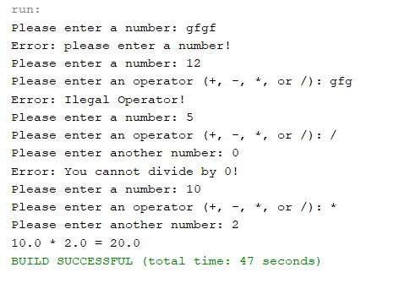

**Part B:**

//summary: This program does not use an exception handler to find errors in inputs of a simple caculator. This caculator can

//add, subtract, multiply, and divide.

//name: Jenna Wolf

//class: Fundamentals of Programming, CS155 - 01

//instructor: Dr. Art Kazmierczak

//date: 11/06/2023

import java.util.Scanner;

public class Main

{

public static void main(String[] args)

{

Scanner input = new Scanner(System.in); //names the input

String temp; //holds the temp data

double num1 = 0, num2 = 0; //holds the num1 and num2 data and sets it to 0

char operator; //holds the operator data

//asks for and takes in number for num1

System.out.print("Please enter a number: ");

temp = input.nextLine();

for(int i = 0; i < temp.length(); i++)

{

//checks to make sure an number was entered. if not error occurs and loop is reset

if(!Character.isDigit(temp.charAt(i)) && temp.charAt(i) != '.')

{

System.out.println("Error: Please enter a number!");

temp = input.nextLine();

i = -1;

}

}

num1 = Double.parseDouble(temp); //sets num1 to temp after converting to double

//asks for and takes in operator

System.out.print("please enter an operator (+, -, *, or /): ");

operator = input.nextLine().charAt(0);

//makes sure that a proper operator was entered. if not, error occurs

while(operator != '+' && operator != '-' && operator != '*' && operator != '/')

{

System.out.println("Error: Please enter a operator!");

operator = input.nextLine().charAt(0);

}

//asks for and takes in number for num2

System.out.print("Please enter a number: ");

temp = input.nextLine();

for(int i = 0; i < temp.length(); i++)

{

//checks to make sure an number was entered. if not error occurs and loop is reset

if(!Character.isDigit(temp.charAt(i)) && temp.charAt(i) != '.')

{

System.out.println("Error: Please enter a number!");

temp = input.nextLine();

i = -1;

}

//checks to make user is not dividing by 0. if so, error occurs and loop is reset

if(temp.equals("0") && operator == '/')

{

System.out.println("Error: You cannot divide by 0");

System.out.print("Please enter a number: ");

temp = input.nextLine();

i = -1;

}

}

num2 = Double.parseDouble(temp); //sets num2 to temp after converting to double

//based on the operator, statement is output and caculations are made

if(operator == '+')

System.out.println(num1 + " + " + num2 + " = " + (num1 + num2)); //+ operator

else if(operator == '-')

System.out.println(num1 + " - " + num2 + " = " + (num1 - num2)); //- operator

else if(operator == '*')

System.out.println(num1 + " * " + num2 + " = " + (num1 * num2)); //* operator

else if(operator == '/')

System.out.println(num1 + " / " + num2 + " = " + (num1 / num2)); // / operator

}

}

**Output:**

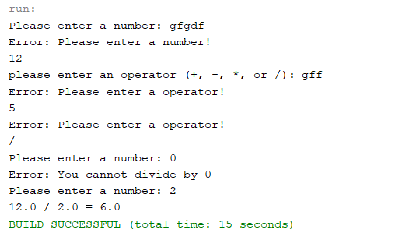

**Program Twelve Part Two:**

//summary: This program uses the inputmismatchexception class to make sure two integers are input. It then finds the sum

//of the two integers.

//name: Jenna Wolf

//class: Fundamentals of Programming, CS155 - 01

//instructor: Dr. Art Kazmierczak

//date: 11/06/2023

import java.util.Scanner; //lets the scanner class be used

import java.util.InputMismatchException; //lets the inputmismatchexception be used

public class Main

{

public static void main(String[] args)

{

Scanner input = new Scanner(System.in); //names the input

int num1 = 0, num2 = 0; //holds the num1 and num2 data and sets it to 0

boolean valid = false; //holds the valid data and sets it to false

//asks the user to input two integers

System.out.println("Enter two integer: ");

while(!valid) //checks to see if valid is false

{

try{ //goes until user enters something that is not an int

num1 = input.nextInt(); //takes in users input

num2 = input.nextInt(); //takes in users input

valid = true; //sets valid to true

}

catch(InputMismatchException ex) { //catches when non int inputs are made

input.nextLine(); //clears the input line

System.out.println("Input is invalid, please enter two integers!"); //outputs an error statement

}

}

//outputs num1 and num2 as well as there sum

System.out.println(num1 + " + " + num2 + " = " + (num1 + num2));

}

}

**Output**

